Switched Networks

Circuit switching is developed for the most part telephone numbers.

Bandwidth is the distance between the highest frequency and the lowest that can go through a medium. Modulation means change in the frequency to have more power to have the signal being able to travel. When u have a large bandwidth not one channel will have it, all channels will share it. Frequency Division Multiplexer(FDM). Each user is given a time slot to use the whole bandwidth, which comes to TDM which is time division multiplexer. WDM is wavelength division multiplexer, each link is referred to as a channel. If ther are a lot of user connected to the network but a limited amount of channels you will be granted access to it if not you would have to try again. For example your trying to make a phone call but if all lines are busy you would have to try it again once the network opens up.

Message switched is not widely used these days because what we do here is all the messages should be transferred or then stored inside the switched and then transferred to another switch. The most common for message switched networks use would be emails.

A circuit switched network is made of a set of switches conneted by physical links in which each link is divided into n channels.

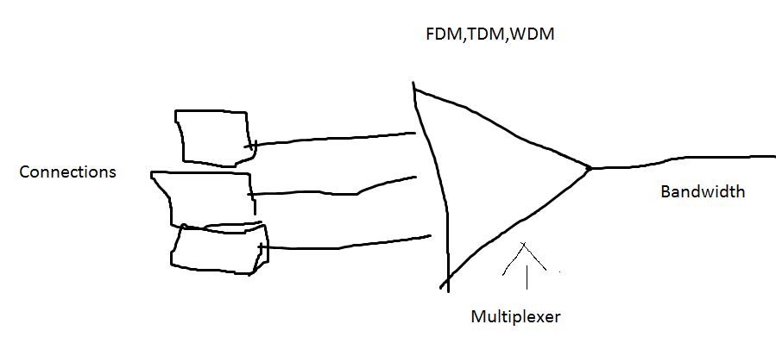

In figure 8.3 A is trying to communicate to M. A will send a request for connection to M. I is the switch and will look for a channel, if there is nothing it will be blocked, if there is a channel it will route the packet through. This is the data link, if it gets approved then you can start with data transfer from A to M until one of them is willing to terminate the communication and then then either the sender or the receiver will send a teardown message. In circuit switching all the resources will be allocated exclusively for that communiavation. What are these resources? The bandwidth, the processing time, no wasting time time.

There is no sharing in each channel, or in any of the resources.

Channel is part of the physical link, The physical link is part of the path. Path is different then medium.